Backgammon game project report

By Mikolaj Gackowski

The following report outlines the development of the backgammon game submitted. I hope that after reading it the code and design decisions will become clearer. The project has undergone changes from the initial design, responding to the knowledge of opportunities and limitations of the Java programming language.

Research and field array concept

During the first weeks of the module my idea of how the back end of the program would work has not changed much. Still, I thought it was a good idea to brainstorm. I have gathered with my colleagues from the Interaction Design course at the beginning of the project to revise for the exam and before we started coding, we also wanted to have a quick session of throwing ideas of how the game might be programmed. When we left, each of us could take a concept they felt good with and start to code.
While the solutions proposed for storing the positions of checkers were diverse (a separate class, storing checker objects in an array, 2d arrays etc.), I have decided to stay with a single array of integers. I felt that the simplicity of having a single array of integers would be invaluable when handling, saving and loading game data. Also, since I was always fond of mathematics, I thought that utilising positive and negative numbers for values could allow for some neat tricks and could save writing additional code if I could just multiply values by (-1) when necessary to switch the sign.

I feel it is important to outline how the array works:

BAR | Visible pointers (triangles from 1 to 24) |  |  |  |  |  |  |  |  |  |  |  |  |  |  |  |  |  |  |  |  |  |  |  | BAR
0 | 1 | 2 | 3 | 4 | 5 | 6 | 7 | 8 | 9 | 10 | 11 | 12 | 13 | 14 | 15 | 16 | 17 | 18 | 19 | 20 | 21 | 22 | 23 | 24 | 25
0 | 2 | 0 | 0 | 0 | 0 | -5 | 0 | -3 | 0 | 0 | 0 | 5 | -5 | 0 | 0 | 0 | 3 | 0 | 5 | 0 | 0 | 0 | 0 | -2 | 0

A zero value means that there is no checker on the field (pointer). Positive values represent numbers of red checkers, while negative values correspond to numbers of black checkers.
Also, I have decided to use indices 0 and 25 as the bar. When a red checker is centered, it would be moved to index zero. Restoring it to play would be a simple addition operation (zero + value of die = destination). Black checkers would be moved to index 25, since they have to be restored from the opposite side of the board. The also move in the opposite direction, so the formula looks more like: (25 + (value of die * modifier) = destination), where the modifier = -1. Whenever the game is processing the movement of black checkers, this modifier would often be applied to switch the direction of movement.

The remaining concepts are pretty self-explanatory, but I kept a record for myself in case I had to leave coding and would return to it later. Here is an example:

27 Nov 2012

17:24 - Changing the way dice are handled when a double is rolled. PROBLEM: to get values from outside Player class, three accessors are needed for die1, die2 and doubleRolled.
SOLUTION: all variables replaced with an array "dice" storing values for four dice. Values are generated for dice[0] and dice[1]. Values [2] and [3] are zero by default and will be updated with duplicates of values [0] and [1]. This keeps the number of different variables and confusion to a minimum.
Also, now the methods generating dice rolls can return dice[] as a single int[].

How I got along

This program is definitely the most complicated one I have ever written that is so richly documented and following conventions and principles of Object-Oriented Programming. Here is what I did in order, along with a reflective comment.
- Thinking of ways to display the board using ASCII. I started of this because it was fun. I like to design these things and thanks to that I had an early concept of the interface from the beginning. Very helpful.
- Creating the array storing checkers. For the third time had to remind myself how to make these properly. I think it clicked this time. They're less of an enigma every time.
- Displaying the board. The first big challenge, but fun all along, probably because I knew it was not necessary and I was just doing it for myself. I split that code into two methods – one that would handle displaying the board and one that would determine which checkers to print based on the values in the array. Finishing that gave me a significant edge from day one in terms or appearance.
- Test method to change values in the array and refresh the board. I felt a great sense of achievement after this, because it proved that the whole concept of an integer array with positive and negative values wasn't crazy.
- Player class and rolling dice – had to refresh myself on the random stuff, but nothing too complicated. There were many ways to get the dice data and after some thought I settled on a method returning an array. The original design document stating that dice would be marked as used (assigned a value of zero) was very helpful.
- Making a move. The biggest, most complicated class that took a few days to develop and actually proved to be a challenge with all the troubleshooting and debugging. I compiled it step by step, making it more and more complicated. At first it only worked for one player. If I wanted to make it work for both, I would have to write twice as much code, if it wasn't for the modifier idea...
- Added the modifier idea. The „make a move” method only required some necessary tweaks now. At the beginning of each turn, the player is determined, loaded into a temporary object and a (1) or (-1) value is loaded into the modifier variable.
- Lots and lots of debugging until it finally worked.
- Menus. A good opportunity to finally solidify my use of switches. They couldn't be used earlier due to the comparative nature of conditions, but they suited menus perfectly. After all that hard work, this seemed a bit more fun.
- Saving the game. The code from previous exercises came in very handy. Really glad I only planned to use one array. The only modification was to have the code save data from multiple variables.
- Loading the game – again, the program had to read lines selectively to assign them to proper variables. Since I understood the concept well, I had no problems and the first test was successful. Implementing this also had the additional benefit – I could now write a scenario into the text file, which would happen much later in the game, to test things like bearing off and winning conditions.
- Checking for winning conditions. This took much longer than it should because of one little sign was wrong. Really glad that's over. My lesson? Get more sleep.
- Bonuses such as rules and whatever the time allowed.

How I strived for good design

At first I hoped that I would be able to implement a GUI. In the first weeks we even planned sound! Unfortunately, time costraints and the fact that I have to work on multiple projects were the reasons why I had to change some things in the design. Still, as I went on, I strived to create a good experience.
Reliable. The code utilises many if...else statements and a couple of try...catch ones that would not allow the user to enter invalid values and break the code. Some might be still there, but it's been a while since I've seen an out of bounds error. After each big change I tested the game and even played with other people for a bit.
User-friendly. While the GUI is not there, I am always trying to print useful information, such as the number of dice to help users make informed decisions. The program has a hint system that takes the value of dice and displays moves that might be done with a particular checker, so that the users don't have to make the maths themselves.
Presentable. Even without the graphics, I have given care and attention to make the ASCII interface look nice and resemble a real board. I had to implement a special method and I'm pretty proud about it.
Easy to pick up. The game has the same classic rules of backgammon as a traditional board ones and I tried to incorporate all of them. However, even if the user has never played the game before, I have included a rules section which will hopefully jelp new users jump into the game with more ease.
Addictive. I felt like personalising the experience creates unique memories which people want to come back to and relive. The players are referred to by name which they can enter themselves. When resuming a saved game, you can even have a preview of these names before you decide to load the file.

Though it may sound cliched, I do believe that little changes can make a big difference.

Evaluation

As I wrote, this is the biggest, most complicated program I have ever written. In four months I feel like I can say I can actually achieve something useful in Java. But it's not only about the complexity of the program – the way how it's structured and documented all conform to the norms and are (hopefully) closer to industry starndards that my previous programs.
I have already spent a whole section explaining the individual things I have learned, but I think I should write more about what I would still hope to learn and achieve if I have more time. Actually, having the GUI was never a high priority – but I definitely wanted to have a computer player. This didn't work out because of my busy schedule. But I think that if I had enough time I could design and implement a method looking for all possible moves and selecting a random one. If I had even more time, I could read on pathfinding theory to make the CPU select the best moves. That would be ambitious, but I am perfectly satisfied with what I have achieved for now.
Looking back at how I worked, I think I managed quite well. It's good that I started early so I could have a bit more peace of mind later on. This proved especially useful since I pretty much tweaked the program to the last hours. So you can never underestimate the importance of thinking of things early. Even if that means that you have to make changes and cuts later on, at least you end up with having two points of view instead of one, and that is very valuable for the future.

I am enclosing the revised statement of requirements below. I have spend considerable time to make sure my code is clear, and I hope this document will be helpful as well. Please enjoy the backgammon game I wrote and have a jolly winter holiday!

Statement of requirements

The final product will be a program that allows users to participate in a simulated backgammon game.
The rules of backgammon will be coded into the product.

The target user is expected to be a person with basic ability to operate a computer, being able to handle
a keyboard. The user will be expected to more or less understand the rules of backgammon, but help will be provided. They will use the final product for entertainment.

The basic program design requires two users to compete against each other by taking turns.

The program will accept user input from the user’s keyboard and and utilise a number generator (rolling dice) to limit the players’ possibilities of movement. The current status of the game would be output through a monitor via the terminal.

The platform of delivery will be a Java program , running as an executable and tested on a Windows machine.

Requirements

Functional Requirements

R1. The program, as a game, shall accept input from two users.
R1.1 The program shall allow to alternate between turns of two players.
R1.2 The program shall allow the current user to roll die.
R1.3 The program shall allow the user to make moves limited to what the dice result allows.

R2. The program shall know when the game is finished.
R2.1 The program should notify the user of that event.
R2.2 The program shall keep the score and modify it accordingly.
R2.3 The program should determine the winner and include that in the notification.

R3. The program shall allow the user to roll two virtual six-sided die.

R4. The program shall follow the rules of backgammon board game.
R4.1 The program shall be able to check for legal moves.
R4.2 The program shall prevent users from making illegal moves.
R4.3 The program may visualise available moves for the player.

R5. The program shall have a menu system for the user to select options.
R5.1 An option of starting a new game will be available.
R5.2 An option to save a game to a text file will be available.
R5.3 An option to load a game from a text file will be available.
R5.5 The program may direct the user back to the menu after a finished game.

R6. The program shall utilise an ability to save the current state of the game to a text file.

R7. The program shall utilise the ability to load a game from a previously saved text file.

R8. The program shall display the current score of the game to the user, which shall be corresponding to the number of their checkers on the board.

Non-functional Requirements

R9. The program shall be available as an executable program.

R10. The program may include a screen displaying rules to new players.

R12. The program may allow a single player to face a virtual opponent.

User Interface

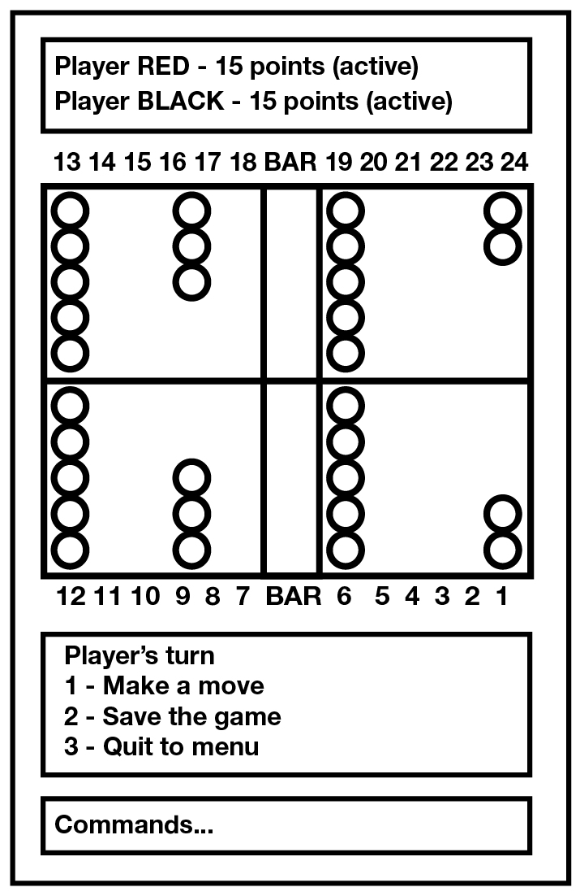
Below is a basic image showing what the interface/menu are likely to look like. Focus is made on creating a presentable ASCII board and an eventual GUI version might be produced if time allows.
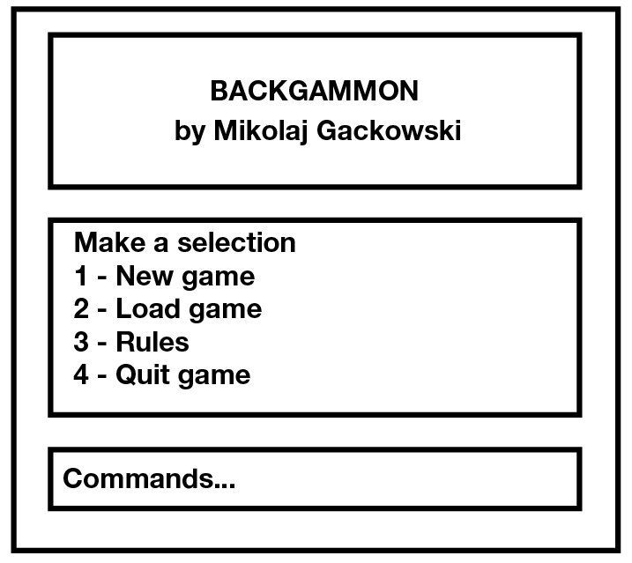

Use Cases

 | A1 | Start a game | Alternatives
1 | System | Displays main menu
2 | User | Selects 'new game' | A1.1
3 | System | Prompts for player names
4 | User | Enters player names
5 | System | Sets up new board with checkers on starting positions
6 | System | Prompts players to roll dice to determine the first player
7 | User | Rolls die
8 | System | Starts the first turn

 | A1.1 | Load a game | Alternatives
1 | User | Selects 'Load Game'
2 | System | Finds text file and asks user if it should be loaded
3 | User | Responds
4 | System | Loads fields, scores, names and active player info
5 | System | Sets up board in response to the retrieved info
6 | System | Prompts active player to start turn

 | A1 | Make a move | Alternatives
1 | System | Displays menu at the beginning of a turn
2 | User | Selects to roll dice and start turn | A2.1
3 | System | Rolls dice
4 | System | Prompts the user to select a checker
5 | User | Selects a checker
6 | System | Prompts the user to select destination
7 | User | Selects destination
8 | System | Performs move according to set of rules
9 | System | Repeats 4-5 until all dice have been played | A2.2
10 | System | Handles the turn to the other player

 | A1.1 | Save a game | Alternatives
1 | User | Chooses to save game at the beginning of turn
2 | System | Stores position of checkers, user data and active user to a text file
3 | User | Confirms
4 | System | Goes back to mid-game menu.

 | A2.2 | Win | Alternatives
1 | System | Checks if the user reduced their score to zero
2 | System | Displays a congratulation screen
3 | System | Informs if a gammon or backgammon was lost
4 | User | Confirms
5 | System | Goes back to main menu

Classes

Candidate Classes

Candidate Classes | Accept / Reject | Reason for rejection
product | Reject | “Product” encompasses the whole program.
program | Reject | “Program” encompasses the whole product.
user | Reject | See: player
backgammon | Reject | It’s a name/condition.
game | Reject | Refers to the whole program.
rules | Reject | Incorporated as a method in ‘board’.
person | Reject | See: player
ability | Reject | Might be part of the ‘player’ class.
computer | Reject | It’s the whole system.
keyboard | Reject | Part of user interface.
entertainment | Reject | Irrelevant.
board | Accept | -
version | Reject | Quality of whole system.
player | Accept | -
input | Reject | More suitable for function.
generator | Reject | Part of ‘dice’.
dice | Reject | Incorporate into Player.
possibility | Reject | Incorporated as a method in ‘board’.
movement | Reject | Incorporated as a method in ‘board’.
score | Reject | Incorporated into ‘player’
terminal | Reject | Part of the user interface.
command | Reject | No information needs to be stored.
usability | Reject | It defines requirements.
platform | Reject | Part of the system.
checker | Reject | Part of ‘board’
interface | Accept | -

Class Descriptions

Board
Stores information of in-game situation, checks legality of moves and allows
to perform them.
Fields:
  - Amount and colour of checkers on each spike (array) - red for positive, black for negative
Methods:
  - Update/retrieve checker positions
  - Set up board and create players
  - Set first player
  - Move checker
  - Check for a win

Player
Stores information of a user, whether it's their turn and performs operations on die.
Fields:
  - Player name
  - Player’s turn
  - Player’s score
  - Die values
Methods:
  - Set/update data
  - Roll dice
  - Mark dice as used

Interface
Handles the player’s interaction with the game and displays current situation and menus.
Fields:
  - The board
  - The players
Methods:
  - Display menus
  - Display board/scores/dice
  - Test method
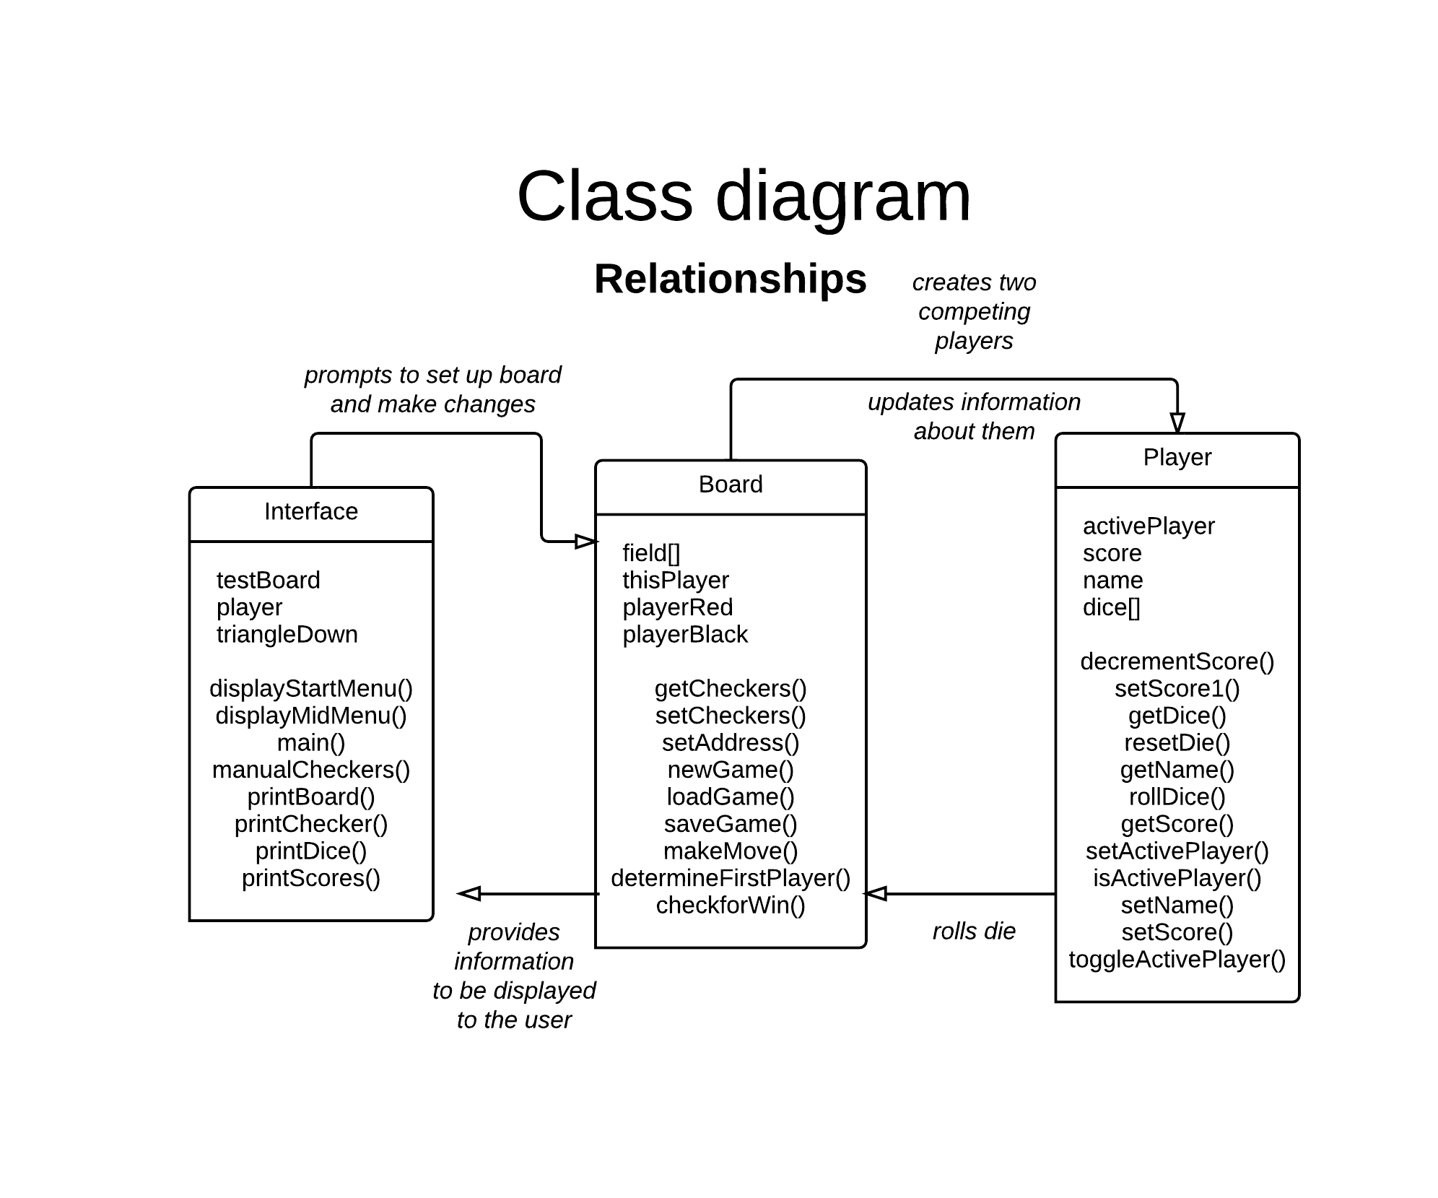
  - Play game (main)

Activity Diagrams

These remained relatively unchanged since I have written them in response to rules of backgammon rather than a particular program.
